Case 4-A106-ME-Israel-Masada-Lamp-Clay-74 CE

**Case No.: 4**

**Accession Number: A106**

**Formal Label:** Israel-Masada-Lamp-Clay-74 CE

**Display Description:**

מצדה‎‎ *metsada* or "fortress" is the ancient fortification in southern Israel on an isolated rock mesa on the eastern edge of the Judaean Desert, overlooking the Dead Sea, where Herod the Great (37-31 BCE) built a large fortress and two palaces as a refuge for himself in the event of a revolt. In 66 CE, a group of Jewish rebels, the Sicarii, overcame the Roman garrison of Masada with the aid of a ruse *(*Murphy-O'Connor and Cunliffe 1997: 378–381*).* After the destruction of the Second Temple in 70 CE, additional members of the Sicarii joined their brethren. According to Josephus, the Sicarii were an extremist Jewish splinter group antagonistic to a larger grouping of Jews referred to as the Zealots, who carried the main burden of the rebellion. The siege of Masada by Roman Legion X at the end of the First Jewish–Roman War 73-74 CE supposedly ended in the mass suicide of 960 Sicarii rebels and their families hiding there. This lamp was excavated by Yigael Yadin in 1963 from pit 6B on the Casemate wall.

**LC Classification:** NK4680

**Geographical Area:**

**Map: Masada**

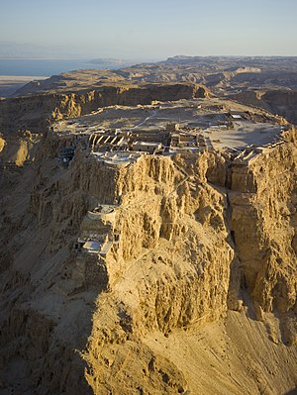 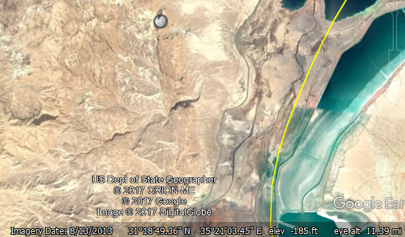

Fig. the promontory of Masada, <https://upload.wikimedia.org/wikipedia/commons/thumb/1/14/Israel-2013-Aerial_21-Masada.jpg/435px-Israel-2013-Aerial_21-Masada.jpg>; Fig. Google Earth

**GPS Coordinates:** [31°18′56″N 35°21′13″E](https://tools.wmflabs.org/geohack/geohack.php?pagename=Siege_of_Masada&params=31_18_56_N_35_21_13_E_type:event)

**Cultural Affiliation:** Sicarii

**Geographical Area: S Israel**

**Medium:** Terracotta

**Dimensions**:   
**Weight: 102 g, 3.5 oz**

**Provenance:**

**Condition:**

**Discussion:**

Controversies surround the discrepancies between archaeological findings and Josephus' writings. Josephus mentions only one of the two palaces that have been excavated, refers only to one fire, while many buildings show fire damage, and claims that 960 people were killed, while the remains of only 28 bodies have been found (Rodgers 2006). bv

The year of the siege of Masada may have been 73 or 74 CE *(*Cotton 1989). "The date of the fall of Masada: the evidence of the Masada papyri". Zeitschrift für Papyrologie und Epigraphik. **78**: 157–62.

**the putative mass suicides at Massada.**

References:

Cockburn, Patrick. 1997. “Ancient battle divides Israel as Masada 'myth' unravels; Was the siege really so heroic, asks Patrick Cockburn in Jerusalem,” *The Independent*, 30 March.

Cotton, H. M. 198). "The date of the fall of Masada: the evidence of the Masada papyri". Zeitschrift für Papyrologie und Epigraphik, 78: 157–62.

Josephus, Flavius. The Wars of the Jews, or History of the Destruction of Jerusalem. Translated by William Whiston, Project Gutenberg, Book IV, Chapter 7, Paragraph 2.

Murphy-O'Connor, Jerome; Cunliffe, Barry. The Holy Land. Oxford Archaeological Guides (5th ed.). Oxford University Press. pp. 378–381.

Negev, Avraham and Shimon Gibson. 2001. *Masada. Archaeological Encyclopedia of the Holy Land.* New York and London: Continuum. p. 322.

Rodgers, Zuleika. 2006. *Making History: Josephus and Historical Method*. Boston: Brill Academic Publishers, Inc.

Sussman, Varda. 2009. Greek and Hellenistic wheel- and mould-made closed oil lamps in the Holy Land: collection of the Israel Antiquities Authorit. Oxford : Archaeopress.